TOPIC 5.11 : KRUSKAL'S ALGORITHM FOR MINIMUM SPANNING TREE
Problem Statement
Given a graph represented by an edge list, implement Kruskal's Algorithm to find the Minimum Spanning Tree (MST) and its total weight.
Test Case 1
Input:
n = 4
m = 5
edges = [(0, 1, 10), (0, 2, 6), (0, 3, 5), (1, 3, 15), (2, 3, 4)]
Output:
Edges in MST: [(2, 3, 4), (0, 3, 5), (0, 1, 10)]
Total weight of MST: 19
Test Case 2
Input:
n = 5
m = 7
edges = [(0, 1, 2), (0, 3, 6), (1, 2, 3), (1, 3, 8), (1, 4, 5), (2, 4, 7), (3, 4, 9)]
Output:
Edges in MST: [(0, 1, 2), (1, 2, 3), (1, 4, 5), (0, 3, 6)]
Total weight of MST: 16
Aim
To write a program that finds the Minimum Spanning Tree of a given graph using Kruskal’s Algorithm.
Algorithm
- Start
- Sort all edges in non-decreasing order of weights
- Initialize parent and rank arrays for disjoint set union
- For each edge (u, v, w):
  - If u and v belong to different sets, include this edge in MST and union the sets
- Continue until MST contains (n-1) edges
- Return MST edges and their total weight
- Stop
Input and Output
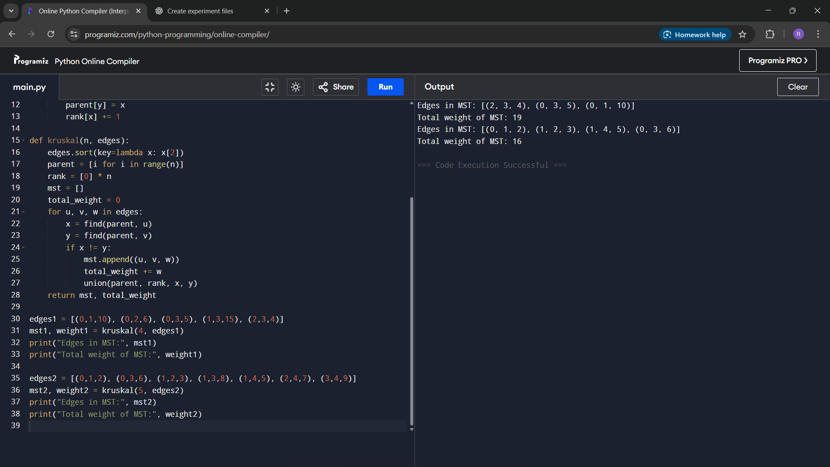
Result
The program successfully finds the Minimum Spanning Tree and calculates its total weight using Kruskal’s Algorithm.
Performance Analysis
Time Complexity: O(m log m) for sorting edges, plus nearly O(m α(n)) for union-find
Space Complexity: O(n) for disjoint set data structures

